Testing with the small scale: TIPRE CS02
https://www.amazon.com/gp/product/B0CJJNMW1Z/ref=ppx_yo_dt_b_search_asin_title?ie=UTF8&psc=1

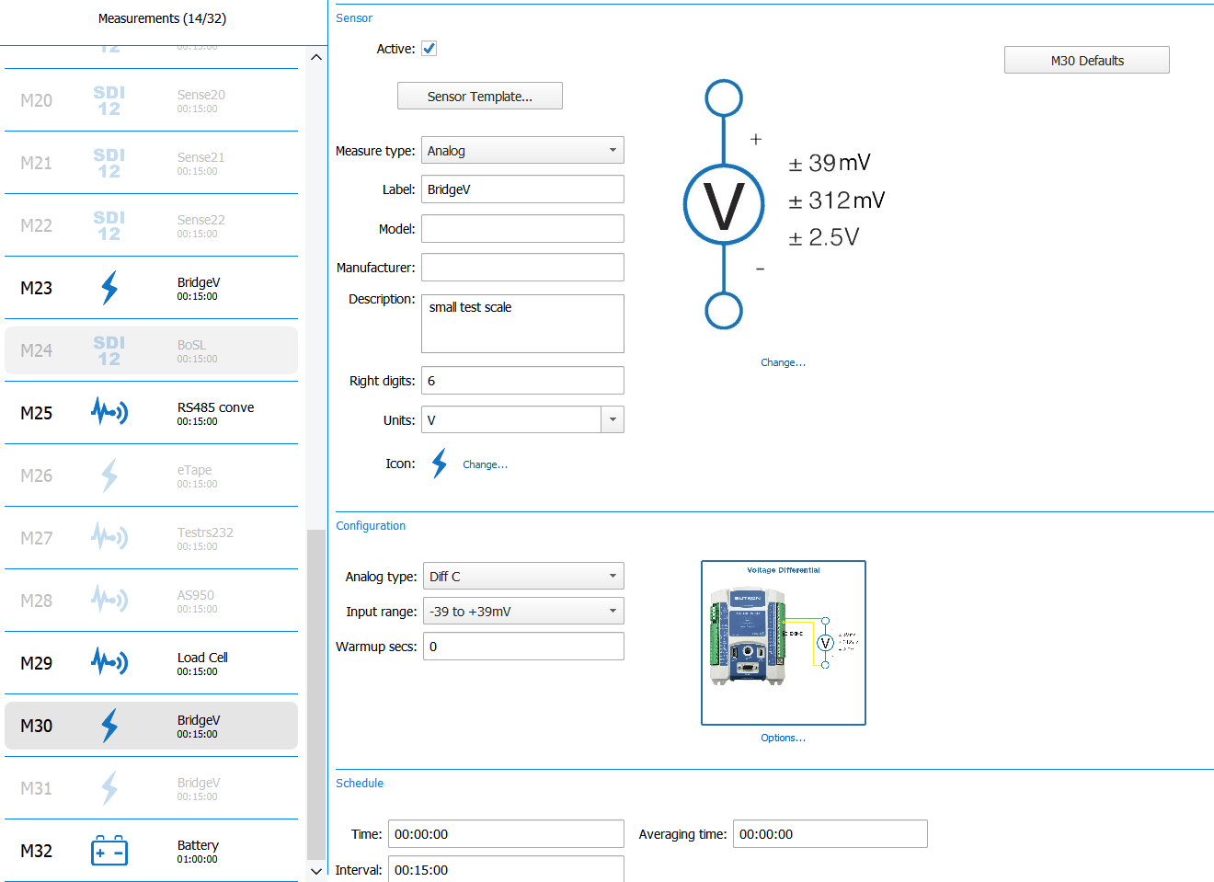

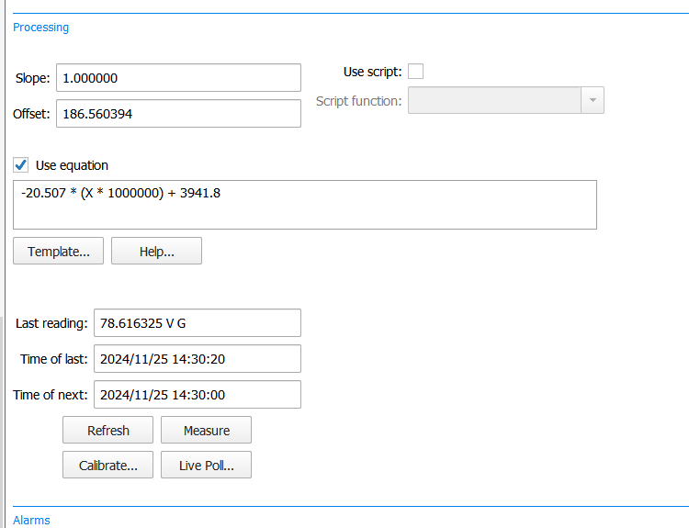
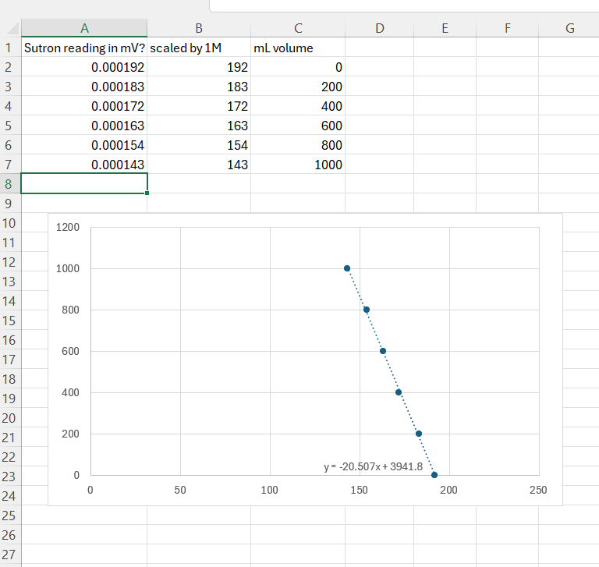
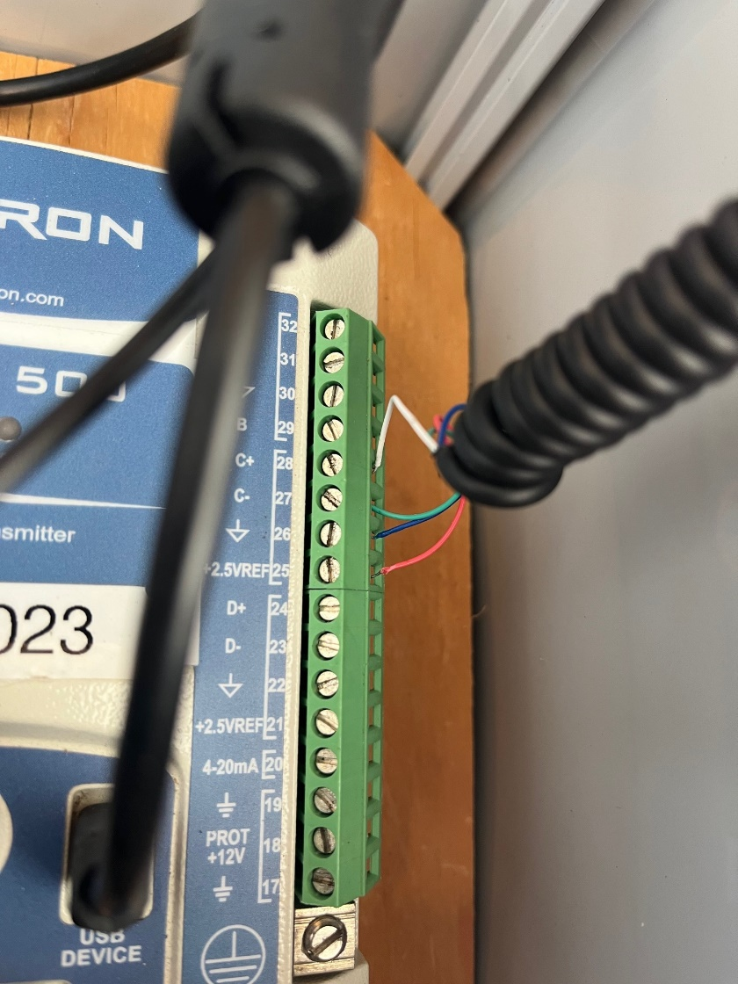

Hacked scale:
Angel USA 400 Pound Capacity Digital 16.75 X 13.75 Inches Stainless Steel Platform Postal Shipping Scale
https://www.amazon.com/gp/product/B01LXRW17R/ref=ppx_yo_dt_b_search_asin_title?ie=UTF8&psc=1

